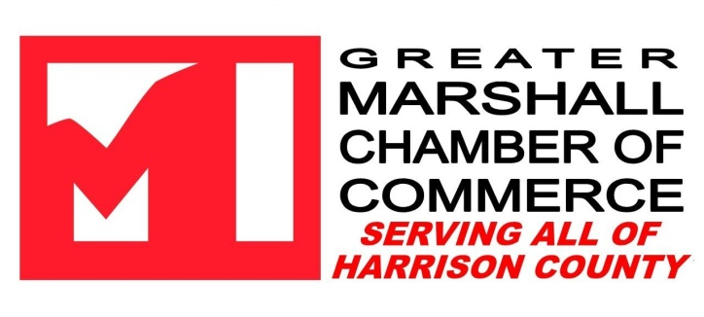

Dear Community Partner,

The Chamber Board, Staff, and Ambassadors thank you for your generous donation of _________________________________________ to the 2023 Annual Chamber of Commerce Banquet: Building a Stronger Community Together. We look forward to having you or your organization represented at this year’s Silent Auction!
Your donation is integral in making our annual fundraising successful, and contributes to the overall operation of the Chamber as a non–profit organization. Our mission remains our primary goal as we strive to better the economic, civic and cultural well-being of our area.
Please see https://marshalltexas.com/ for all community events, and do consider joining us at the annual banquet! As always, we appreciate your partnership in the community throughout the years, and look forward to being a valuable resource for you.

With thanks,
Stacia Runnels, Executive Director
Kim Brown, Director of Programs & Events

