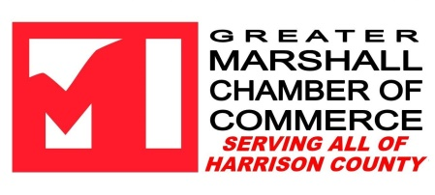
Presents the Annual Chamber of Commerce Banquet and Awards
“Building a Stronger Community Together”
April 18, 2023 Marshall Convention Center

Sponsoring the Banquet provides your business with the unique opportunity to engage community members, reaching across Harrison County with your name and brand. We’re anticipating 400+ people at this annual event, and would love to have YOU on board!

Sponsorship Opportunities

Community Visionary – $4,000 Title Sponsor
2 tables, on-stage recognition, listing in program, headlining listing on sponsor banner at the event, headlining logo on website and Facebook, listed in rotating emails, opportunity to provide company logo item/gift to each guest, opportunity for speaking role such as the Pledge of Allegiance or Invocation.

Community Cultivator- $2,500 (4 Available: Silent Auction, Entertainment, Reception, Dinner)
1 table with premium location, on-stage recognition, listing in program, prominent listing on sponsor banner at the event, prominent logo on website and Facebook, listed in rotating emails.

Community Leader – $1,500 (Five Available: Decor, Program, Citizen of the Year Award, Ambassador of the Year, & Community Achievement Award) 1 table with premium location, on-stage recognition, listing in program, listing on sponsor banner at the event, name on website and social media, listed in rotating emails.

Community Advocate – $1,000 (Ten Available)
1 table, listing in program, listing on sponsor banner at the event, name on website and social media, listed in rotating emails.
Friends of the Community Table Sponsor $500
1 table for 10 people, listing in the program.
Individual Tickets $50, $80 per couple
It is our hope that you will consider sponsoring the 2023 Banquet and Awards, as we will celebrate those who are truly the heart of our community. We ask for your commitment no later than April 4, 2023. If you have any questions, please contact our office, we will be happy provide an invoice for your payment and records. 935-7868
Sincerely,
Stacia Runnels
Executive Director

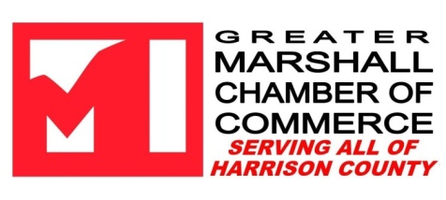
Sponsorship Agreement for the 2023 Annual Chamber Banquet

Sponsor Name to be Displayed: ______________________________
Contact Name: _________________________________________
Phone: ______________________Email: ____________________

SPONSORSHIP LEVELS

- Community Visionary - $4000
  - Community Cultivator - $2500
  - Community Leader - $1500
  - Community Advoacate- $1000
  - Friends of the Community Table Sponsor $500
  - Individual Ticket $50
  - Couples Tickets $80
Please submit commitment by April 4, 2023 to info@marshalltexas.com
Please submit payment by event date of April 18, 2023
Payment available in-office, online at marshalltexas.com or request invoicing at the above email.

