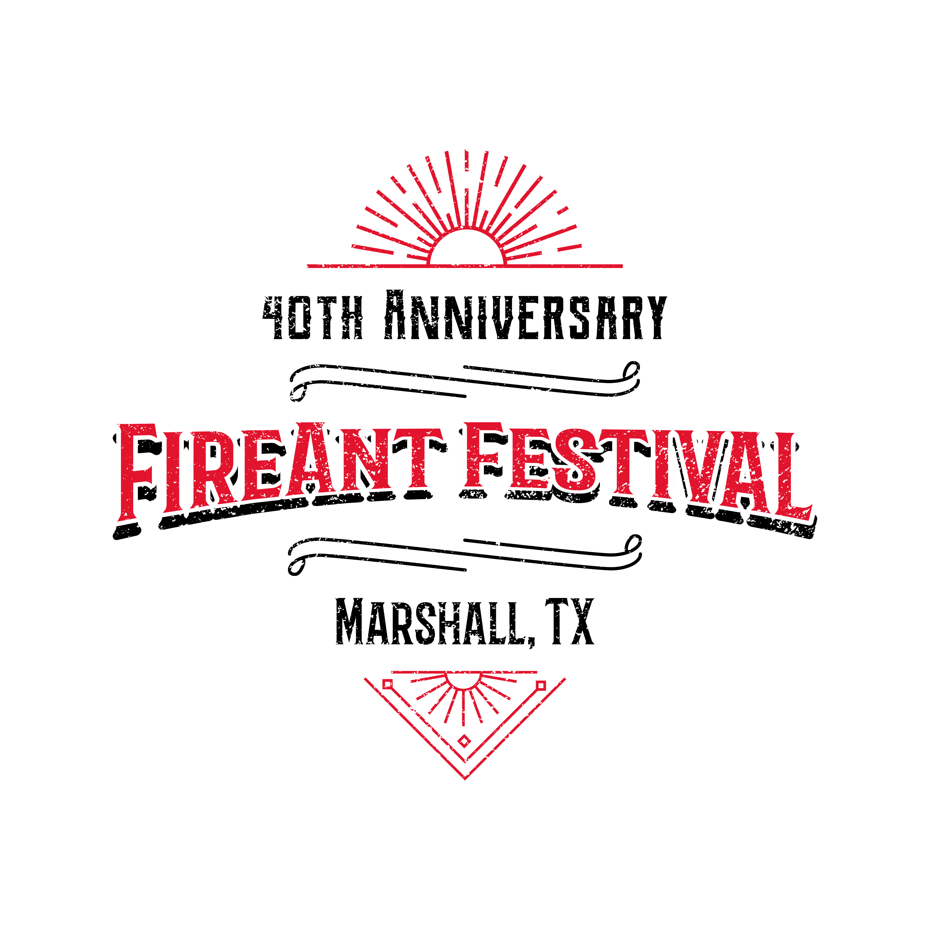

CUPCAKE BATTLE
SATURDAY, OCTOBER 8, 2022
1:30 P.M.
Joe Pine Coffee Co.

RULES

- Bring 6 cupcakes to Joe Pine Coffee Co., 207 N. Washington Ave, Marshall, TX 75670.

- All cupcakes must be in standard cupcake liners.

- Judged on taste, texture, presentation, and creativity.

- Extra points will be added for cupcakes with FireAnt Festival theme: “40 Years of FireAnt!”

- Bring an index card stating the type and ingredients of your cupcake. Include your name on the back of the index card.

Check in:

Contestants must check in and set up between 1:00 - 1:30 p.m. Winners will be announced at 2:15 p.m.

2022 FIREANT FESTIVAL CUPCAKE BATTLE

Please check the appropriate category:
□ Adult-Professional (Anyone that sells baked goods) □ Youth-Amateur (18 and under)
□ Adult-Amateur

Contestant #: _____________________________

Name: _________________________________________________________

Address: _______________________________________________________

Phone: ____________________________________Age: ________________
E-mail address: __________________________________________________

