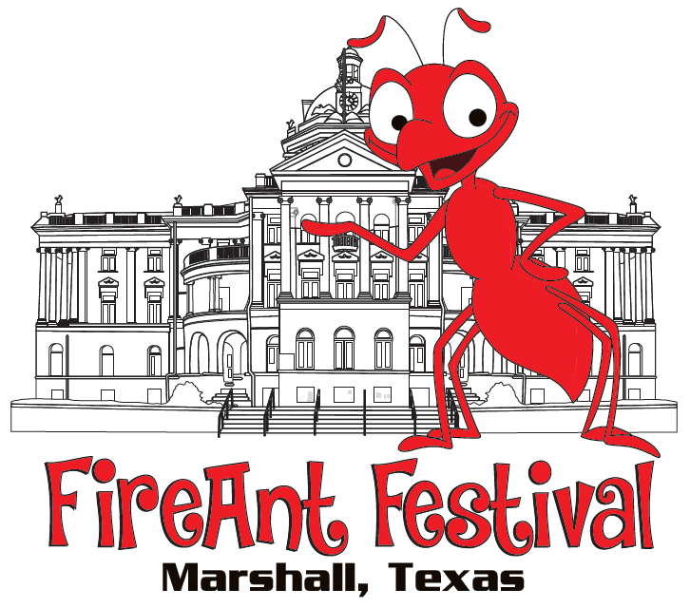
40th Annual FireAnt Festival

October 8th, 2022 Sponsorship Opportunities

______________________________________________________________________________
Master of the Mound $5,000  Headlining Sponsor of FireAnt Main Stage  Your customized logo’d banner on the festival stage, + single sided 3’ x 6.5’ retractable banner at the podium.  Name and Logo will be featured on:  - 5,000 Festival brochures  - Festival Main Stage Banner with logo  - Greater Marshall Chamber of Commerce website and social media  - FireAnt Festival social media  Name will be featured in BOLD on:  5K and Tour de FireAnt t-shirts  Talk of East Texas & 92.3 the Depot press  Hourly Recognition on Stage  Signature Sponsor Sign for your business  King of the Hill $3,500  Headlining Entertainment Sponsor  Sponsored VIP seating  Custom Signage on stage  Name and Logo will be featured on:  - 5,000 Festival brochures  - Greater Marshall Chamber of Commerce website and social media  - FireAnt Festival social media  Name will be prominently featured on:  5K and Tour De FireAnt t-shirts  Talk of East Texas & 92.3 the Depot press  Hourly Recognition on Stage  Signature Sponsor Sign for your business  Queen Ant $2,500  Headlining Sponsor of FireAnt Parade  Exclusive logo’d banner leading parade  Names & logos will be featured on:  - 5,000 Festival brochures  - Greater Marshall Chamber of Commerce website and social media  - FireAnt Festival social media  - 5K and Tour De FireAnt t-shirt feature  Talk of East Texas & 92.3 the Depot press  Hourly Recognition on Stage  Custom Event Sign to post at your business  Contact the Chamber for more information: 903-935-7868  Commit by Sept.2, Pay by September 23 | Friends of Freddy Ants $1,500  Headlining Sponsor of a FireAnt Signature Event: Toddler Trot/Diaper Derby, FireAnt Kids K, FireAnt Children’s Area  Custom signage displayed at event location  Name will be featured on:  - 5,000 Festival brochures  - Sponsor of a FireAnt Event  - Greater Marshall Chamber of Commerce website and social media  - FireAnt Festival social media  - 5K and Tour de FireAnt t-shirt feature  Talk of East Texas & 92.3 the Depot press  Hourly Recognition on Stage  Sponsor Sign to post at your business  Elvira’s Colony $1,000  Headlining Sponsor of key annual FireAnt Event: Cupcake battle, FireAnt 5K, Tour de FireAnt Bike Ride, Eye Spy contest  Name will be featured on:  - 5,000 Festival brochures  - Greater Marshall Chamber of Commerce website and social media  - FireAnt Festival social media  Recognition on Stage every other hour  Sponsor Sign to post at your business  Sugar’s Fan Club $500  Sponsorship of key hourly FireAnt performances  Name will be featured on:  - 5,000 Festival brochures  - Greater Marshall Chamber of Commerce website and social media  - FireAnt Festival social media  Recognition on Stage every other hour  Sponsor Sign to post at your business  Ant-Thony’s Ants $250  Headlining Sponsor of a key FireAnt contest:  Chicken Chunkin’, Gurning, & More!  Name will be featured on:  - 5,000 Festival brochures  - FireAnt Festival social media  Recognition on Stage every other hour  Sponsor Sign to post at your business

