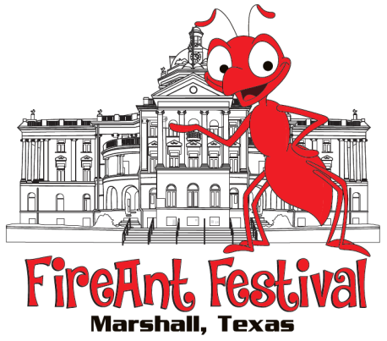
37TH ANNUAL FIREANT FESTIVAL
October 12, 2019 / October 13, 2019 (if rainout)
Product Booth Application
Greater Marshall Chamber of Commerce
(903) 935-7868 FAX (903) 935-9982

Name: _______________________________________________________________________

Business Name: _______________________________________________________________

Mailing Address: _______________________________________________________________

City: ______________________________________ State: __________ Zip: _______________

Telephone: _____________________________ Cell: _________________________________

Email: _______________________________________________________________________

TX Tax ID #: ___________________________________________________________________

List of Products: _______________________________________________________________
_____________________________________________________________________________

A booth will not be assigned without a COMPLETED APPLICATION, FULL PAYMENT, AND JURY SELECTION.

Fee Schedule: $60 for the first 10x10 booth Total Enclosed with Application: $_________
Add $50 for each additional 10x10 booth / Add $10 flat fee if electricity is needed (Product Vendor Only)

Application Agreement: (Please initial each line to accept your understanding. Application must be signed and dated.)

_____ Exhibitors assume all responsibility for their property and agree to maintain their space, merchandise, activities and business practices in compliance with all the laws of the State of Texas. Exhibitors hold such sponsors harmless from all liability, loss or expense on any claims arising out of such exhibitor activities.
_____ I understand that I must send 3 photos of my products by mail or email to info@marshalltexas.com before my booth can be accepted in the FireAnt Festival.
_____ I understand the Festival is a juried show and I can ONLY display the items that have been approved.
_____ If extended an invitation, I agree to comply with the decisions made by the Festival staff.
_____ I understand that there is NO refund for inclement weather. The FireAnt Festival has a contingency plan of Sunday, October 13, 2019, if severe weather is expected on Saturday, October 12, 2019. As there are NO refunds, it is my decision as a vendor as to whether or not I will set up.
_____ I agree that I will NOT dismantle my booth prior to 5:00p.m. unless I receive prior approval.
_____ I understand that I WILL NOT sell or giveaway any food products, drinks or bottle water.

____________________________________________________________ __________________________
Signature Date

