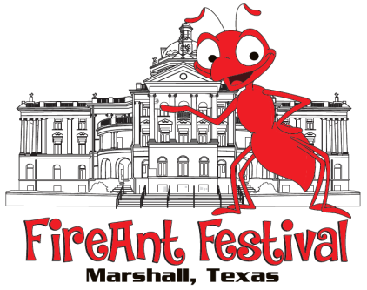
37TH ANNUAL FIREANT FESTIVAL
Saturday, October 12, 2019 October 13, 2019 (rainout)
FOOD VENDOR Application
Greater Marshall Chamber of Commerce
(903) 935-7868 FAX (903) 935-9982

Name: _______________________________________________________________________

Business Name: _______________________________________________________________

Mailing Address: _______________________________________________________________

City: ______________________________________ State: __________ Zip: _______________

Telephone: _____________________________ Cell: _________________________________

Email: _______________________________________________________________________

TX Tax ID #: ___________________________________________________________________
Deadline for receipt of application, detailed menu and payment is September 27, 2019.
In order to maximize the sales opportunity for each food vendor, we limit the number of vendors who sell the same or similar products and limit the total number of food vendors. Spaces will be given on a first come, first served basis. We request a detailed menu, application and payment prior to acceptance.
Health inspection will be completed by the City of Marshall on the morning of the festival beginning at 8:00a.m. DO NOT BE LATE AS YOU WILL NOT RECEIVE A REFUND. Payment of $25 for your health inspection will be made directly to the City of Marshall.

A vendor will not be accepted without a completed application, FULL payment, menu and jury selection.
Fee Schedule: $175 for EACH 10x10 space needed Total Enclosed with Application: $_________
Please accommodate your entire trailer from the hitch to past the back bumper as we can’t move other vendors to accommodate extra space needed. Example: If your trailer is 25 feet long, you will need 3 spaces.

Application Agreement: (Please acknowledge each item with your initials. Application must be signed and dated.)

_____ I understand the Festival is a juried show and I can ONLY sell the items that have been approved. I agree to comply with the decisions made by the Festival staff.
_____ Exhibitors assume all responsibility for their property and agree to maintain their space, merchandise, activities and business practices in compliance with all the laws of the State of Texas. Exhibitors hold such sponsors harmless from all liability, loss or expense on any claims arising out of such exhibitor activities.
_____ I understand that there is NO refund for inclement weather. The FireAnt Festival has a contingency plan of Sunday, October 13, 2019, if severe weather is expected on Saturday, October 12, 2019.
_____ I understand the FireAnt Committee would like my booth to stay open the entire event, but I agree that I will NOT dismantle my booth prior to 5:00p.m.
_____ I understand and agree to the FireAnt Festival policy: NO vendor may sell or giveaway any form of soft drinks, including Coke, Pepsi and Dr. Pepper products or any flavor varieties. I agree to suspend sales if I break this rule. I may submit application to sell lemonade, tea or water, I but understand that limited vendors will be allowed to sell lemonade and/or teas and it will be on a first come, first served basis.

____________________________________________________________ __________________________
Signature Date

