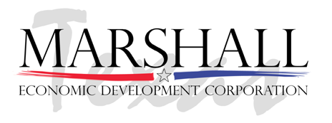

2019 BUSINESS & INDUSTRY LUNCHEON and BUSINESS EXPO

The Greater Marshall Chamber of Commerce and
The Marshall Economic Development Corporation (Marshall EDC)
Tuesday, April 23, 2019 Marshall Convention Center
Sponsored Tables with 8 seats $175 / Individual Tickets $25 each
Business Expo Tables $50 (Limited Number Available)

AWARDS
- Small Business of the Year (1-10 employees)
- Large Business of the Year (11-50 employees)
- Industry of the Year (51+ employees)
CRITERIA: Stimulation of economic growth and /or creation of jobs | Positive work environment | Exemplary customer service | Community volunteerism in Marshall and/or Harrison County.

- Boss of the Year
CRITERIA: An effective leader who engages and leads employees | Creates a positive work environment | Exceeded work activity problem resolution or goal attainment| Demonstrates a commitment to community involvement | Provides exceptional service to customers, vendors and employees

- Employee of the Year
CRITERIA: Provides consistent, exceptional service to customers | Engages and leads fellow employees with a positive attitude | Provides significant contributions to their company | Exceeded work activity problem resolution, or goal attainment objectives | Demonstrates a commitment to community involvement

- Nonprofit Business of the Year
CRITERIA: Demonstrates excellent service to the City of Marshall and Harrison County | Engages and leads our community | Actively engaged current and new members in 2017|Exceeded 2017 organizational objectives to serve the community

Return Nominations by Monday, April 15, 2019, at 4:00p.m. Describe why they deserve this award. Fax your form to 953-935-9982, email to info@marshalltexas.com
or mail to Marshall Chamber of Commerce, P.O. Box 520, Marshall TX, 75671.

