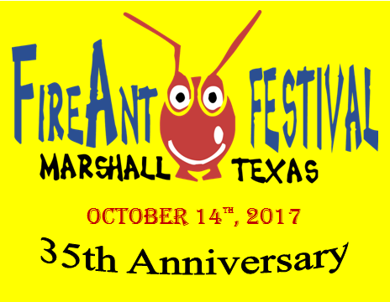
35TH ANNUAL FIREANT FESTIVAL
October 14, 2017 / October 15, 2017 (if rainout)
Product Booth Application
Greater Marshall Chamber of Commerce
(903) 935-7868 FAX (903) 935-9982

Name: _______________________________________________________________________

Business Name: _______________________________________________________________

Mailing Address: _______________________________________________________________

City: ______________________________________ State: __________ Zip: _______________

Telephone: _____________________________ Cell: _________________________________

Email: _______________________________________________________________________

TX Tax ID #: ___________________________________________________________________

List of Products: _______________________________________________________________
_____________________________________________________________________________

A booth will not be assigned without a completed application, full payment and jury selection.

Fee Schedule: $50 for each 10x10 booth Total Enclosed with Application: $_________
If electricity is needed, $60 for the first 10x10 booth and $50 for each additional booth (Product Vendor Only)

Application Agreement: (Please acknowledge each item with an “X”. Application must be signed and dated.

_____ Exhibitors assume all responsibility for their property and agree to maintain their space, merchandise, activities and business practices in compliance with all the laws of the State of Texas. Exhibitors hold such sponsors harmless from all liability, loss or expense on any claims arising out of such exhibitor activities.
_____ I understand that I must send 3 photos of my products by mail or email to info@marshalltexas.com before my booth can be accepted in the FireAnt Festival.
_____ I understand the Festival is a juried show and I can ONLY display the items that have been approved.
_____ If extended an invitation, I agree to comply with the decisions made by the Festival staff.
_____ I understand that I may NOT sell or giveaway any food products, drinks or bottle water.
_____ I agree that I will NOT dismantle my booth prior to 5:00p.m.
_____ I understand that there is not a refund for inclement weather. The FireAnt Festival has a contingency plan of Sunday, October 15, 2017, if severe weather is expected on Saturday, October 14, 2017.

____________________________________________________________ __________________________
Signature Date

