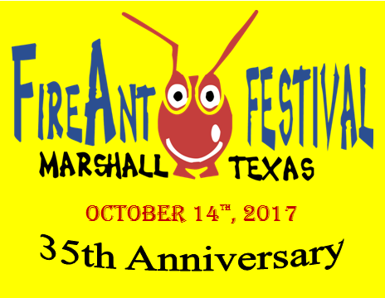
35TH ANNUAL FIREANT FESTIVAL
Saturday, October 14, 2017 October 15, 2017 (if rainout)
FOOD VENDOR Application
Greater Marshall Chamber of Commerce
(903) 938-7868 FAX (903) 935-9982

Name: _______________________________________________________________________

Business Name: _______________________________________________________________

Mailing Address: _______________________________________________________________

City: ______________________________________ State: __________ Zip: _______________

Telephone: _____________________________ Cell: _________________________________

Email: _______________________________________________________________________

TX Tax ID #: ___________________________________________________________________
Deadline for receipt of application, detailed menu and payment is September 27, 2017
In order to maximize the sales opportunity for each food vendor, we limit the number of vendors who sell the same or similar products and limit the total number of food vendors. Spaces will be given on a first come, first served basis.
We request a detailed menu to be emailed to info@marshalltexas.com or mailed with your application and payment prior to acceptance in the 2017 FireAnt Festival. Health inspection will be completed by the City of Marshall on the morning of the festival. Payment of $25 for your health inspection will be made directly to the City staff. A vendor will not be accepted without a completed application and FULL payment.

Fee Schedule: $150 for each 10x10 space needed Total Enclosed with Application: $_________
Measure your trailer from the hitch to the back bumper as we can’t move other vendors to accommodate your booth due to an inaccurate measurement. Example: If your food truck is 15 feet long, purchase 2 spaces. If 25 feet long, you will need 3 spaces. If paying online, please visit www.marshalltexas.com and submit payment at the link on the homepage. If not accepted, you will be notified by email.
Application Agreement: (Please acknowledge each item with your initials. Application must be signed and dated.
_____ I understand and agree to the FireAnt Festival policy which states that no vendor may sell or giveaway any form of soft drinks, including Coke, Pepsi and Dr. Pepper products or any flavor varieties. I may submit application to sell lemonade or teas, I but understand that only three vendors will be allowed to sell lemonade and/or teas and it will be on a first come, first served basis.
_____ I understand the Festival is a juried show and I can ONLY sell the items that have been approved.
_____ If extended an invitation, I agree to comply with the decisions made by the Festival staff.
_____ Exhibitors assume all responsibility for their property and agree to maintain their space, merchandise, activities and business practices in compliance with all the laws of the State of Texas. Exhibitors hold such sponsors harmless from all liability, loss or expense on any claims arising out of such exhibitor activities.
_____ I understand that there is not a refund for inclement weather. The FireAnt Festival has a contingency plan of Sunday, October 15, 2017, if severe weather is expected on Saturday, October 14, 2017.
_____ I agree that I will NOT dismantle my booth prior to 5:00p.m.

____________________________________________________________ __________________________
Signature Date

